Marketing Guide – Health4U

## Background:

Low levels of physical activity are associated with an estimated $117B in annual health care costs. Most of these costs are entirely preventable through moderate amounts of physical exercise and a balanced diet. An estimated 3 in 4 Americans do not get enough physical activity. Diseases such as heart disease and Type 2 Diabetes are easily preventable simply through regular moderate physical activity. As a health care provider, we should always be striving to reduce our costs in a way that doesn’t affect the quality of care we provide to our patients. Our direct costs can be reduced through encouraging our existing subscribers and patients to be heathier through exercise and diet. Through the use of a fitness application, we can directly encourage and incentivize users to care for their health reducing our eventual costs.

## Market background:

The estimated overall market size is 209 million American adults x $3501 per customer = $73B in preventive costs. The immediate market for our company is our existing subscribers which is 12.2 million. We currently have operating costs of $81.1B which amounts to about $6,650 per customer. Using a conservative estimate of reducing costs of 2 million of our subscribers, we can potentially save $700 million which amounts to increasing our operating income by almost 25%. Additional revenue can be gained if we gain health care coverage for more adults because of the appeal of the application.

The market for fitness applications is robust as the current North American market has a value of $17B with projected CAGR of 31% for the next 7 years2. We do not have any direct competitors, but there are two main identified fitness application competitors: MyFitnessPal and Apple Health. MyFitnessPal generated $120 mio in revenue in 2018. MyFitnessPal has an estimated 80 million users. The application is used to track calories through exercise and diet, it also allows users to set goals based on these counters.

Apple Health application does not report directly its revenue as it is overall part of the generic Apple application set that comes pre-downloaded with every IPhone. The application tracks movement and can connect with other applications or devices.

## Product Background and Positioning:

The product we will be releasing is Health4U. The main product value proposition is that by being directly connected to their health care providers, subscribers and patients will be more likely to use the application. Our three main features are:

* Pre-set Goals page to allow users to easily follow a plan
* Easy tracking and personal health data all on one page
* Easy to use and access rewards page to further incentivize users to keep on track with their goals

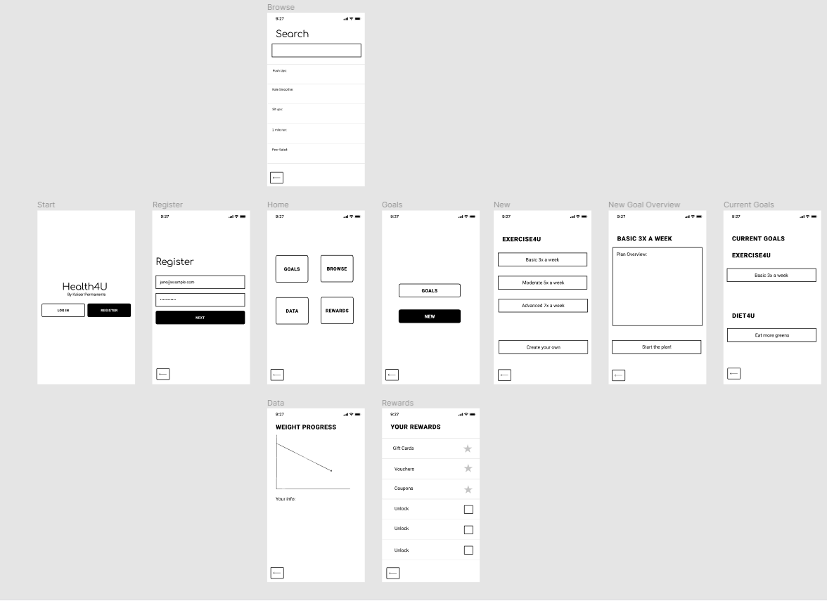

Users can find the application on the Apple App Store or the Google Store.